"Explore the Best of Sikkim & Darjeeling”
(4N/5D)

Discover the beauty of Sikkim and Darjeeling, where majestic Himalayan peaks, serene monasteries, and lush tea gardens create an unforgettable holiday. Explore the vibrant city of Gangtok, visit the stunning Tsomgo Lake and the sacred Baba Harbhajan Singh Mandir, and admire spectacular mountain landscapes. Continue to the charming hill station of Darjeeling, famous for its rolling tea estates, colonial charm, and panoramic views of Mt. Kanchenjunga.

Witness the mesmerizing sunrise from Tiger Hill, visit the historic Ghoom Monastery and the iconic Batasia Loop, and experience the rich culture of the Eastern Himalayas. Perfect for families, couples, and nature lovers, this journey offers the ideal blend of scenic beauty, adventure, and relaxation, creating memories to cherish for a lifetime.

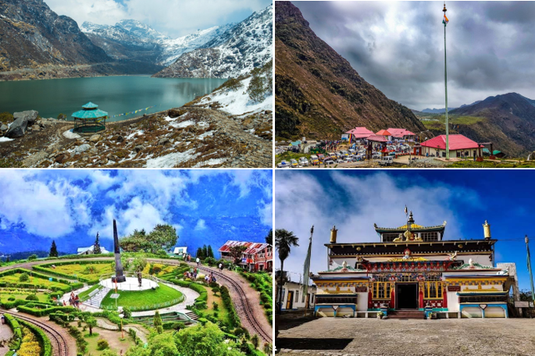
We wish you a happy, safe and unforgettable journey with us
Detailed Itinerary
Day 1: NJP / Bagdogra – Gangtok (130 Km | 4.5 Hrs approx.)
Upon arrival at New Jalpaiguri (NJP) Railway Station or Bagdogra Airport, meet our representative and drive to the beautiful hill town of Gangtok, the capital of Sikkim. Enjoy a scenic journey through lush green valleys, winding mountain roads, and the picturesque Teesta River. Upon arrival, check in to your hotel and spend the evening at leisure exploring the vibrant MG Marg or relaxing amidst the serene surroundings. Overnight stay in Gangtok.
Day 2: Gangtok Sightseeing
After an early breakfast, proceed for a full-day excursion to the breathtaking Tsomgo Lake, a glacial lake situated at an altitude of approximately 12,400 ft, surrounded by snow-capped mountains. Later, visit the revered Baba Harbhajan Singh Mandir, a shrine dedicated to the legendary Indian Army soldier. Enjoy the stunning Himalayan landscapes and, if weather permits, you may opt to visit Nathula Pass (subject to permit availability and at an additional cost). Return to Gangtok in the evening for an overnight stay.
Day 3: Gangtok – Darjeeling (120 Km | 4.5 Hrs approx.)
After breakfast, check out of the hotel and drive to the charming hill station of Darjeeling, famous for its tea gardens and panoramic views of the Himalayas. En route, enjoy the scenic beauty of rolling hills, lush forests, and mountain streams. Upon arrival, check in to your hotel and spend the evening at leisure exploring the local markets or the famous Mall Road. Overnight stay in Darjeeling.
Day 4: Darjeeling Sightseeing
Early in the morning, visit Tiger Hill to witness a spectacular sunrise over Mount Kanchenjunga (weather permitting). On your return, visit the historic Ghoom Monastery and the iconic Batasia Loop, offering breathtaking views of the Darjeeling Himalayan Railway and surrounding mountains. After breakfast, continue your sightseeing with visits to the Himalayan Mountaineering Institute, Padmaja Naidu Himalayan Zoological Park (closed on Thursdays), Tea Garden, and the Tibetan Refugee Self-Help Centre (subject to time). Return to the hotel for an overnight stay in Darjeeling.
Day 5: Darjeeling – NJP / Bagdogra Departure (70 Km | 3 Hrs approx.)
After breakfast, check out of the hotel and drive to New Jalpaiguri (NJP) Railway Station or Bagdogra Airport for your onward journey. Depart with unforgettable memories of Sikkim's serene monasteries, snow-clad mountains, glacial lakes, and Darjeeling's scenic tea gardens and breathtaking Himalayan landscapes. We wish you a safe journey and hope to welcome you again for another memorable holiday.
Tour ends with unforgettable memories
Destination/Nights | 3* Hotel Name
Gangtok /02N
Darjeeling /01N
HOTELS DETAILS:

Package Cost:

3★ Hotels: Rs. per person (Based on 6 guests – Double Sharing Basis)

Inclusion: -
- Breakfast and Dinner Included.
- 0 DBL Room on sharing based.
- 03 Nights in Accommodation in hotel.
- 01 Night in Super Deluxe Houseboat in Alleppey.
- Assistance on Arrival.
- All Transfers and S.S tours by AC Tempo Traveler
Exclusions: -
- 5% GST.
- Flight Tickets are not included.
- Guide.
- Extra meal not included or as per the inclusions given above.
- Vehicle not at disposal.
- No extra pickup or drop included for lunch/sightseeing unless otherwise mentioned in the itinerary.

